**NAME-PANKAJ SATI**

**COURSE-MCA-2A**

**ROLL NO-20711048**



**Problem Statement- Create a wired LAN in packet tracer**

**Objective-** To understand how to create a wired LAN using switch in packet tracer.

**Description-**

**Step1:-drag and drop 4 pc**

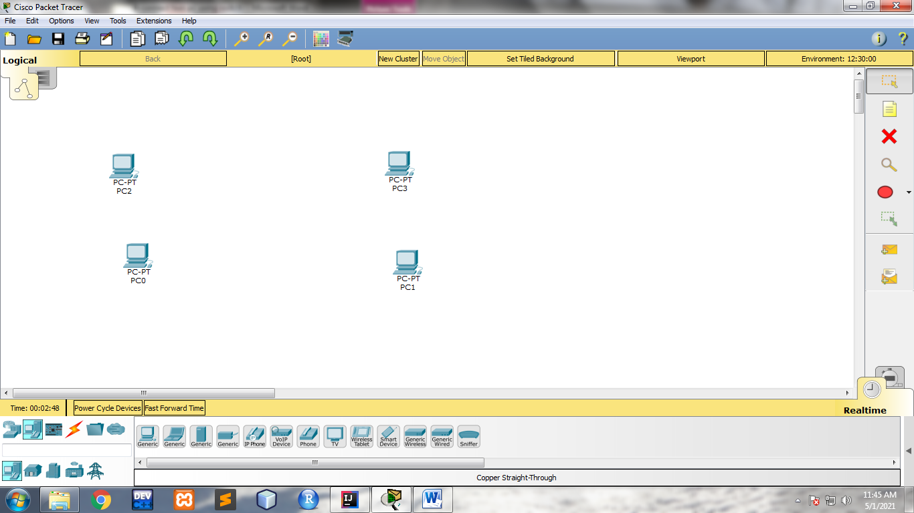

**Step2: drag and drop 1 switch**

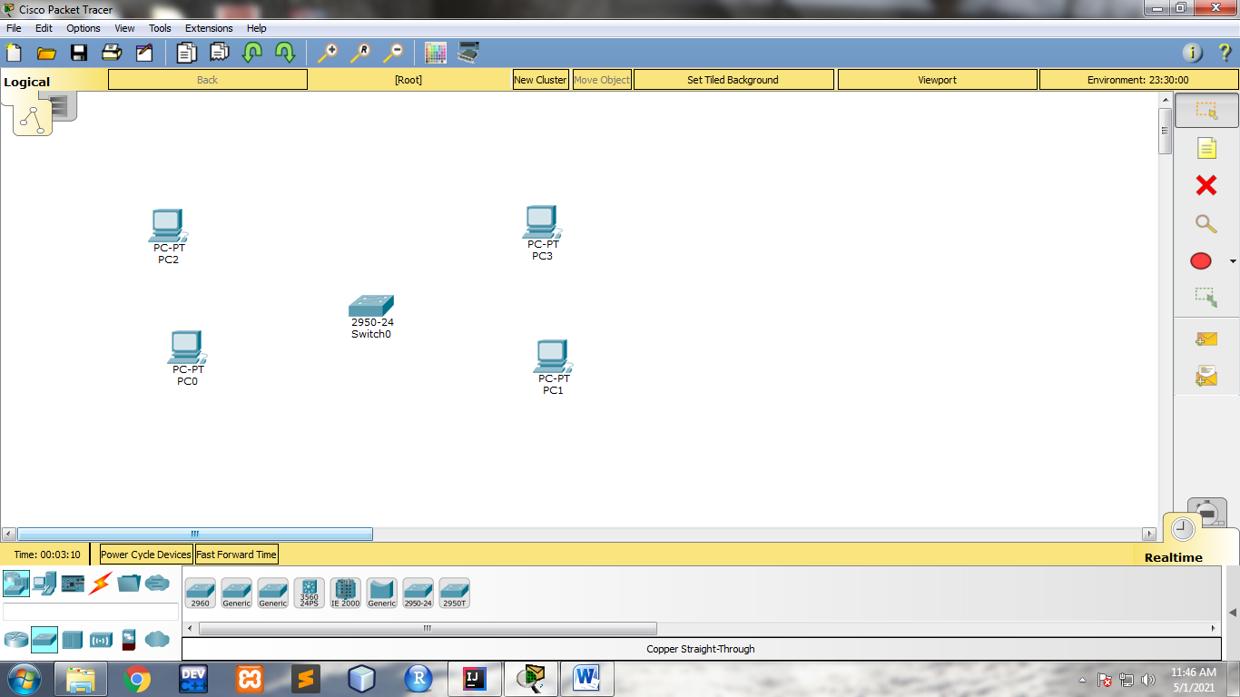

**Step3: connect 4 Pcs fast ethernet to various switch Ethernet ports using copper straight cable.**

**For PC0:-**

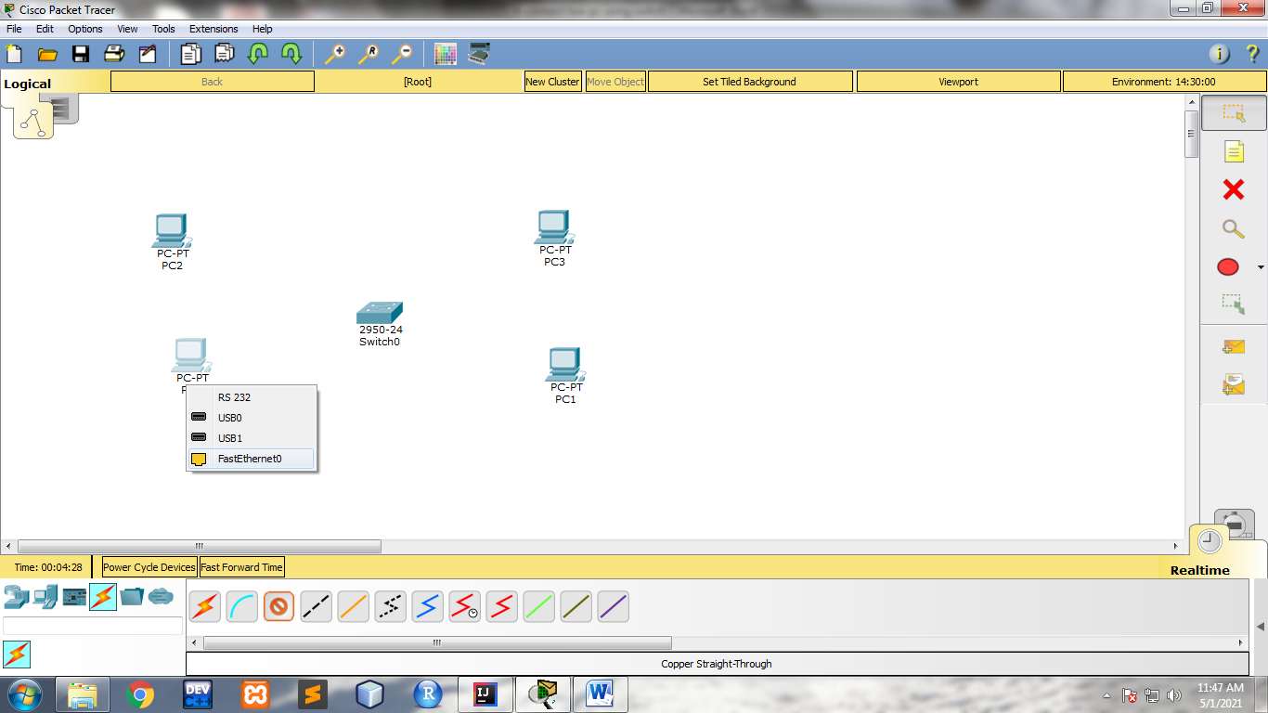

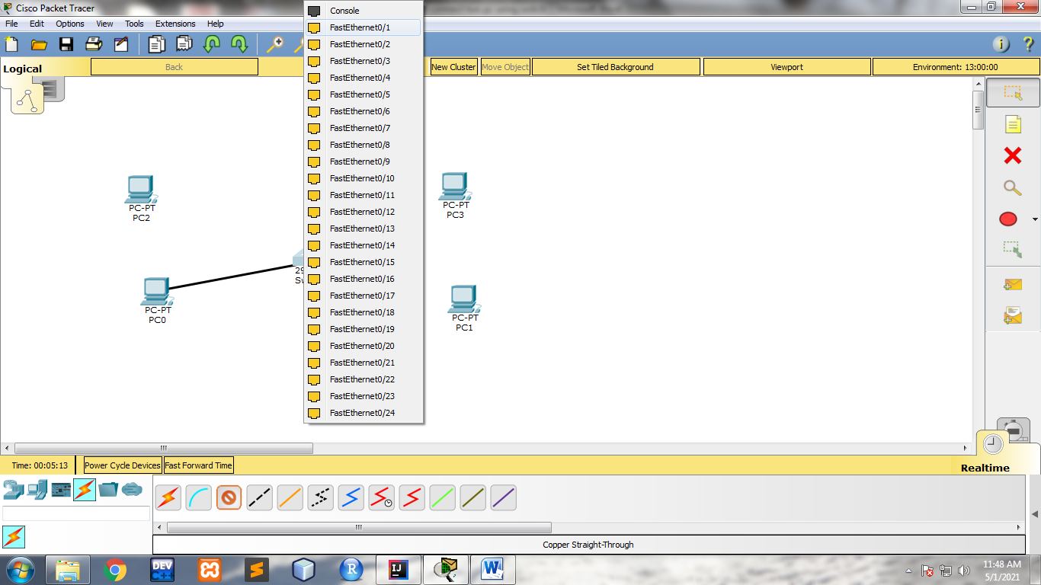

**For PC1:-**

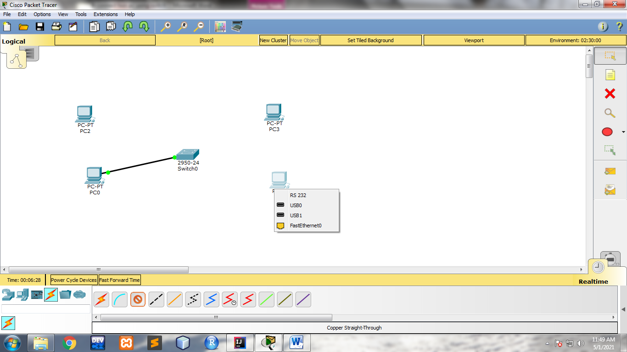

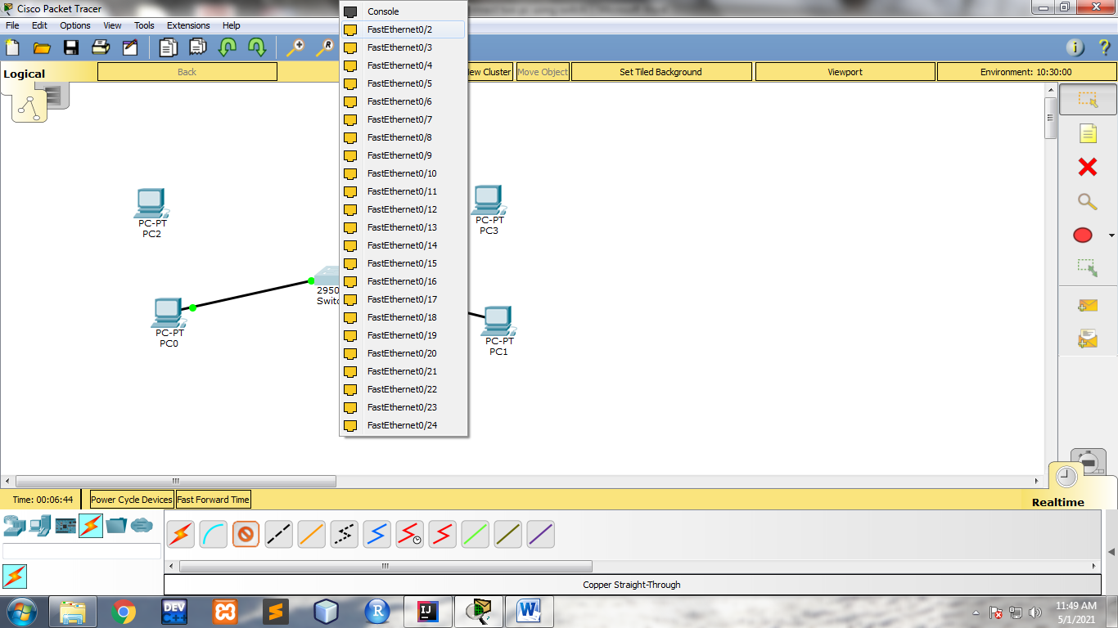

**For PC3:-**

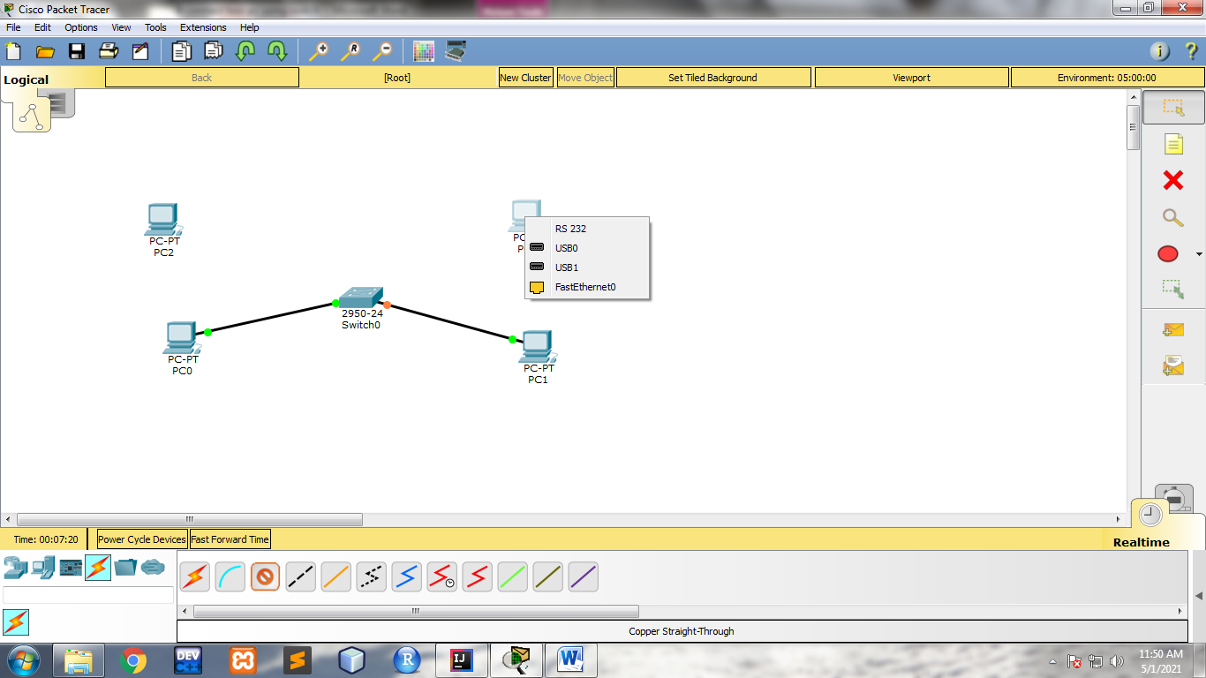

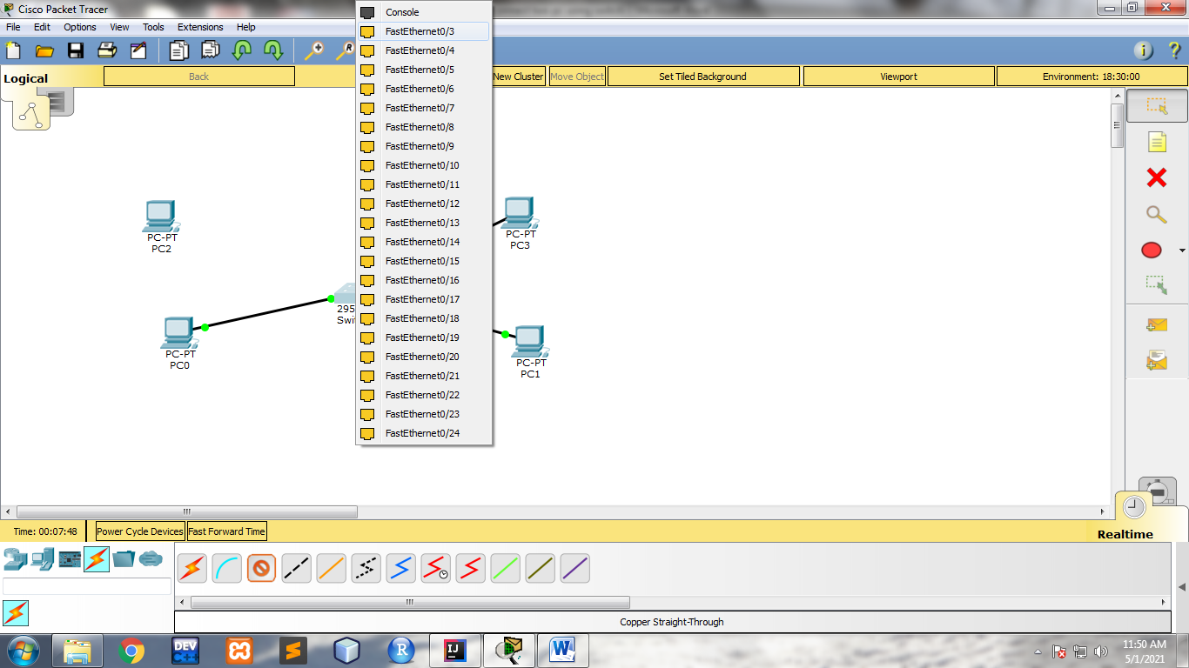

**For PC2:-**

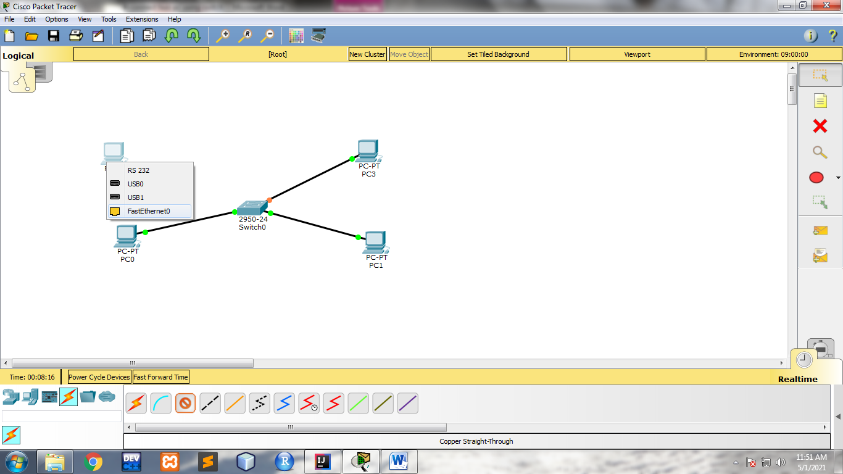

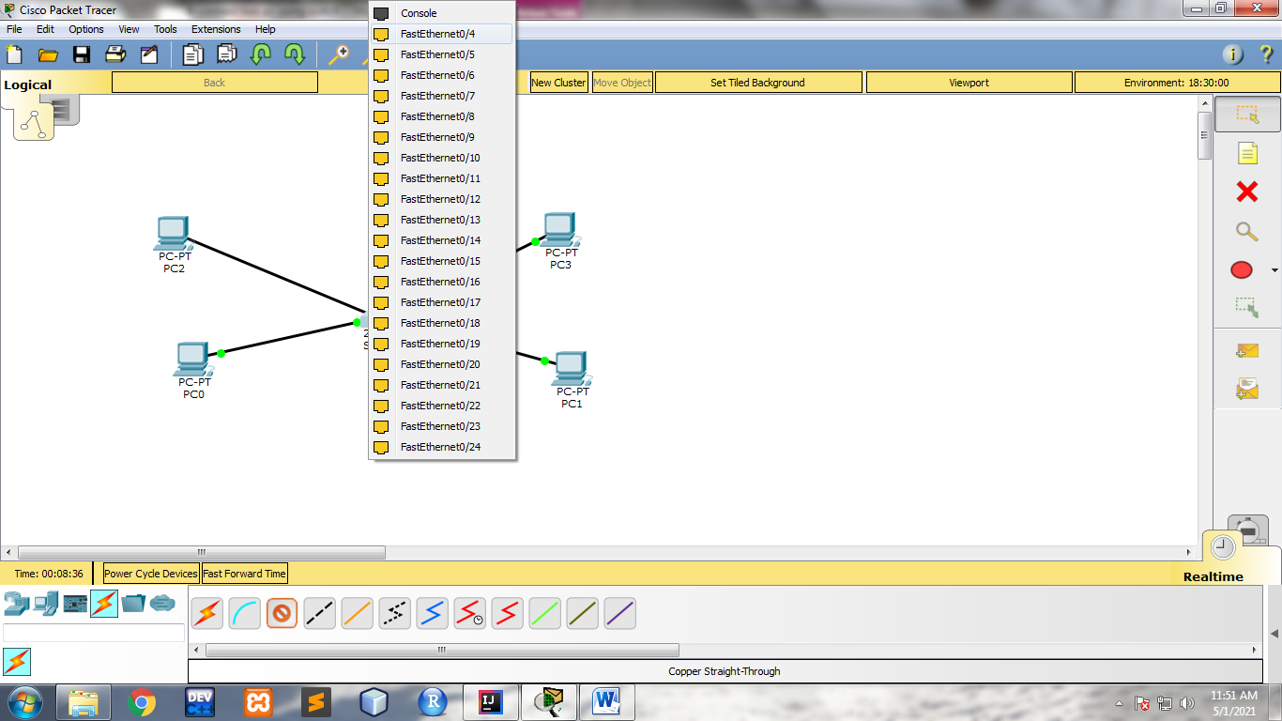

**Final physical configuaration:-**

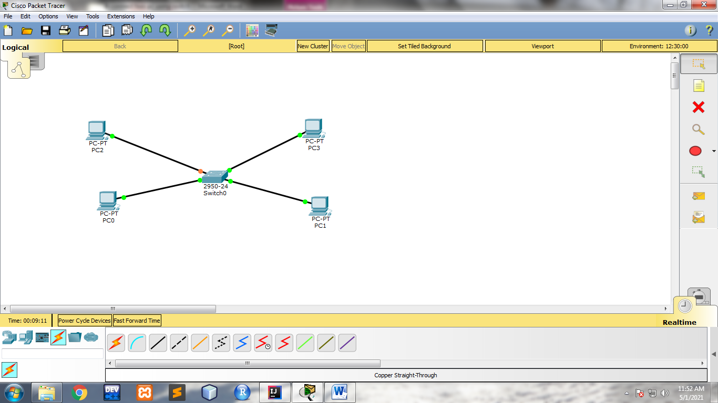

**Step4: configure unique ip address for each pc using IP configuration option**

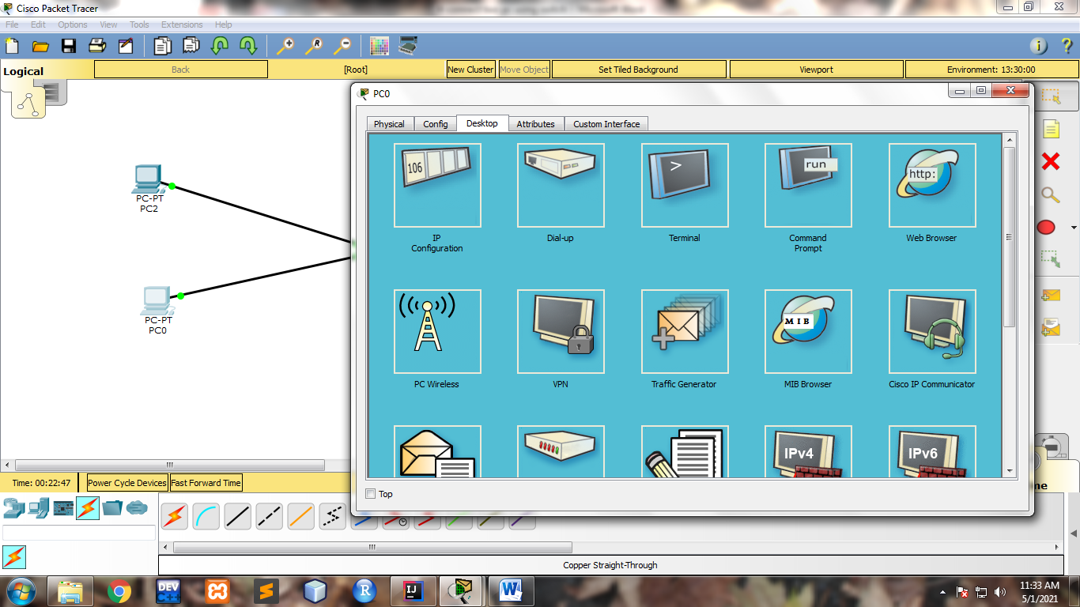

**IP address Configuration FOR PC0:-**

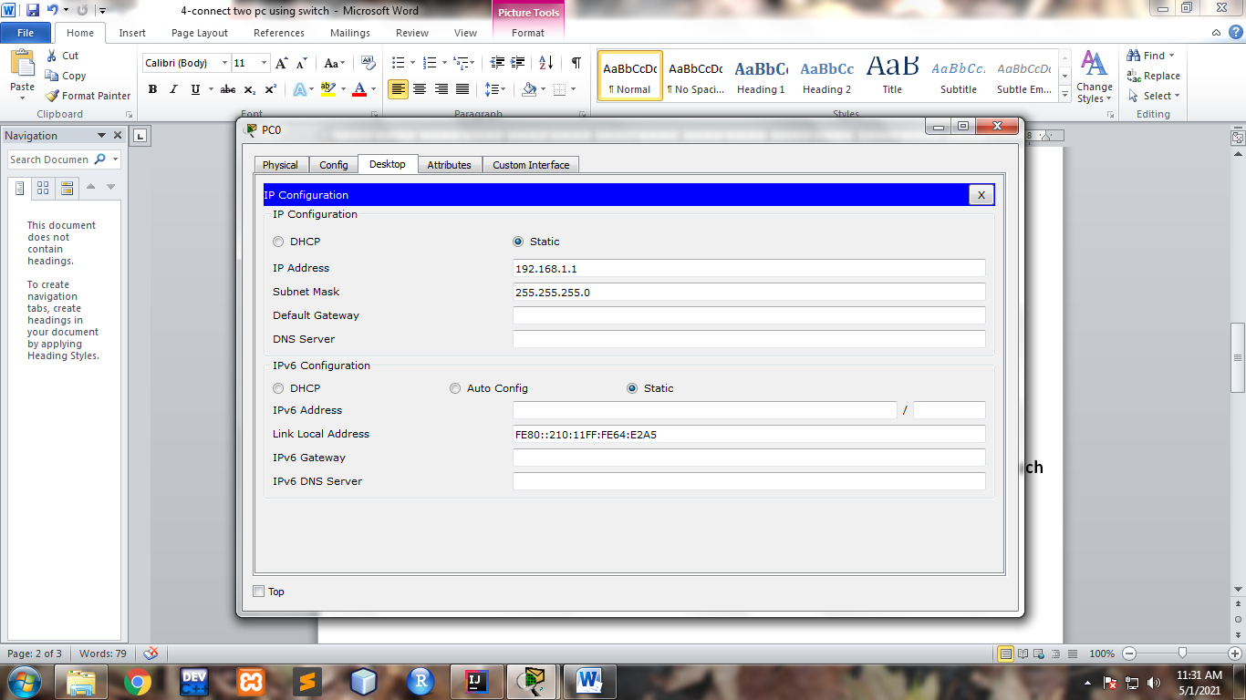

**IP address Configuration FOR PC1:-**

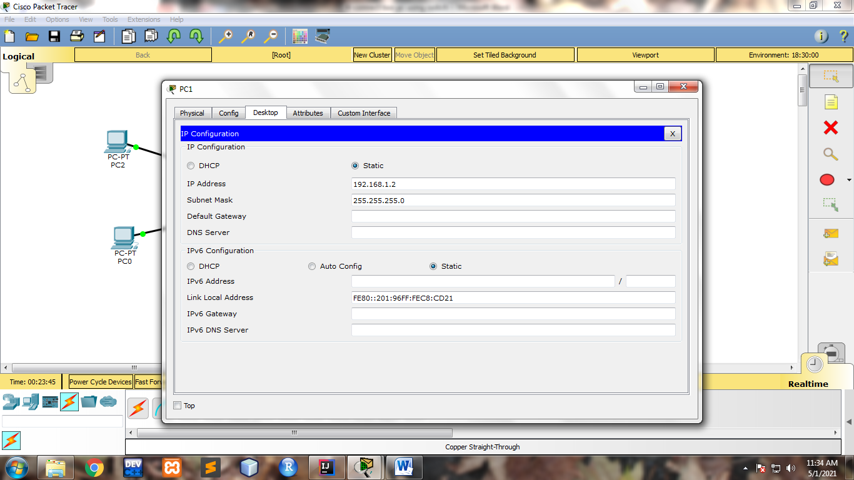

**IP address Configuration FOR PC2:-**

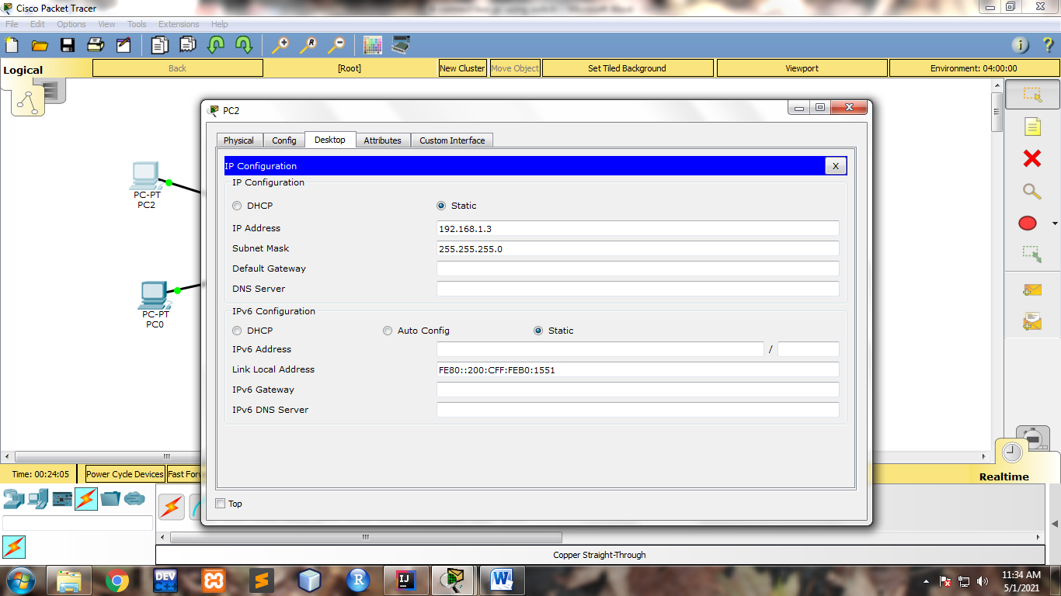

**IP address Configuration FOR PC3:-**

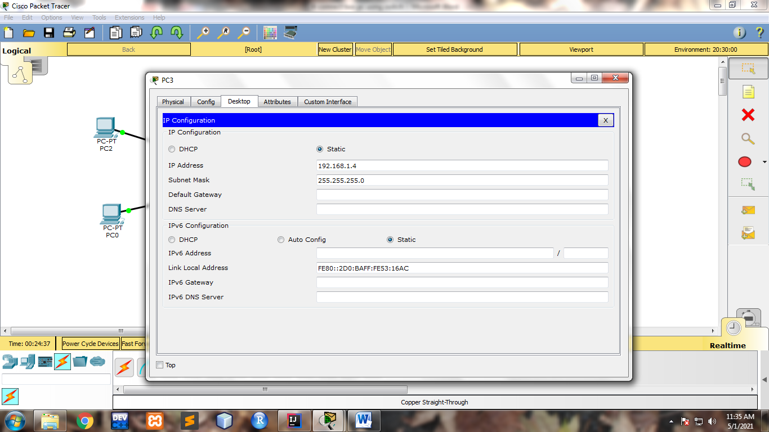

**Step 5: test the connectivity using ping command followed by unique ip address for each pc**

